Original article under: http://www.noz.de/artikel/2524800 from 08.01.2022 11:48
Help for Self-Help

Campus in Ghana grows thanks to support from Emsland area

by Caroline Theiling-Brauhardt. (pics and its annotations added from archive by M. Weber)
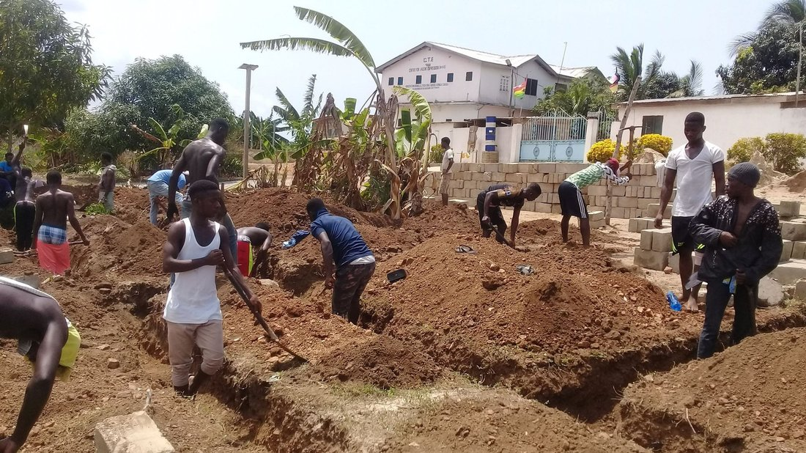
Students work together to develop the campus. (For new Restaurant and Exhibiton Hall – 2021 Weber)

Lingen. The "CTE School Partnership Verein Ghana" founded in Lingen wants to create future opportunities for a boarding school in Ghana. A difficult undertaking in times of the Corona pandemic.

Even without the well-known drum workshops of the African music professor Morphius Eurapson-Quaye, the support association "CTE School Partnership Verein Ghana" succeeded in raising funds for the educational institution "Centre for Talent Expression" (CTE) in Ghana, so that the planned work in Winneba could be continued.

The center helps the poorest of the poor by giving them a professional perspective and is thus an example of how the problems of migration can be effectively counteracted.

Morphius has been in Germany for three months every year since 1996, offering workshops in schools from Flensburg to Recklinghausen in order to raise funds for the educational institution in Ghana, CTE.

He was supported in particular by the Emsland Comprehensive School, where the "CTE School Partnership Verein Ghana" support association was founded in 2016.

In addition to donations, a main source of income are the drumming courses that Morphius offers to students in the Emsland region. For a small fee, he teaches children in classes the music of his homeland, which he has studied all his life. In 2014, a fundraising gala at the Lingen theatre even raised around 22,000 €. The money is administered in Germany and transferred to him as needed.

In the early days, Morphius and his wife trained girls in the skill of sewing in their own living room. In the meantime, a campus has been built on the outskirts of Winneba, where a site has been developed over several years - completely under own direction. A main road leads to the site, where there is also a bus stop, so that students who do not live on the campus can also be taught there.

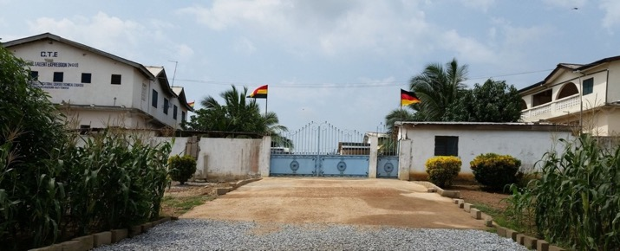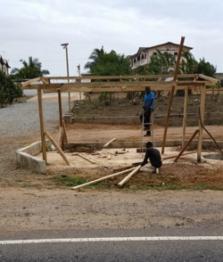
New entrance from main road (2019) – on the left block „Emsland“ and on the right block „Friends of Africa“ – New bus station - 2020
Students currently receive their training in music, theatre, dance, hairstyling and beauty, computers, catering, carpentry, tailoring and other crafts.

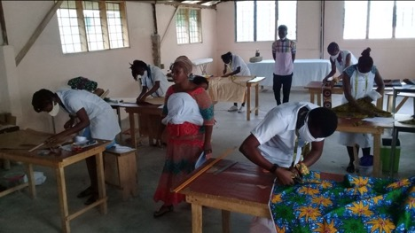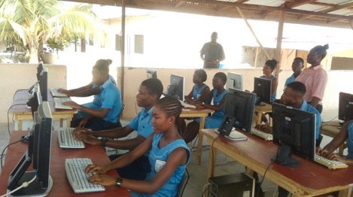
Exam (2021) IT-Training (2021)

In August 2016, on the occasion of CTE's tenth anniversary, a delegation from the Emsland Comprehensive School visited the school in Winneba for the first time and inaugurated a dormitory for boarding students, the construction of which had been financed by the CTE Sponsors' Association in cooperation with schools from the region.

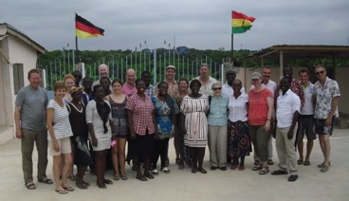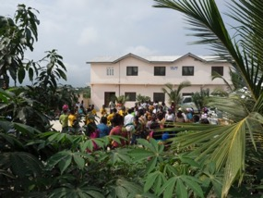
10th Anniversary Celebration – Delegation Emsland & Friends of Afrika – Inauguration Dormatory Building (2016)

A photovoltaic system for the power supply, a well with a water pump and a school bus have also been provided for the CTE. Internet has also been made available there last year.

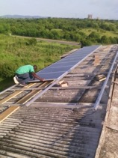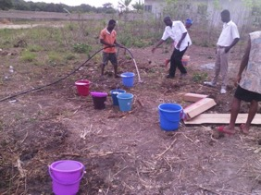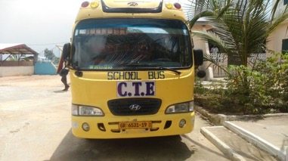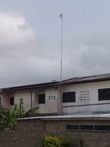
PV System (2017) Well (2018) Schoolbus (2019) Internet (2020)

Currently, more teacher apartments are being built on the site, as well as a hall
in which products produced by the young people will be offered for sale. According to Martin Weber, chairman of the association and former principal of the Emsland Comprehensive School, the apartments for the teachers are important so that the teachers do not incur costs for rent or travel to the school, which in turn would be borne by the association.

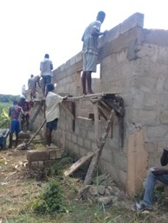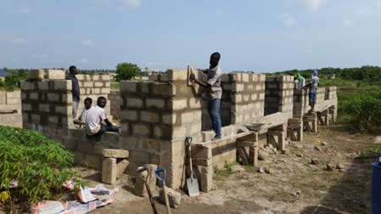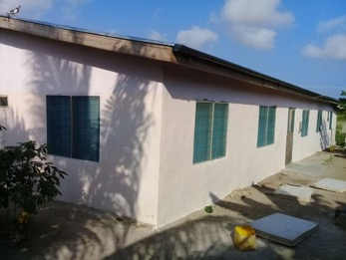
Left - Middle – Shell of building of two Teacher Homes – Right – completed (2021)

Much of the funding Morphius needs for his school comes from the Emsland region. But since the outbreak of the Corona pandemic, the charismatic African has not been back to Europe and thus an important source of donations for his home country has been lost.

"That's why we have now drawn up a budget plan and, as an association, we are covering the costs of insurance, infrastructure and desalinating the well water, for example," Weber explained. Around 10,000 € would be needed to further develop the campus with the second building complex and additional teacher housing.

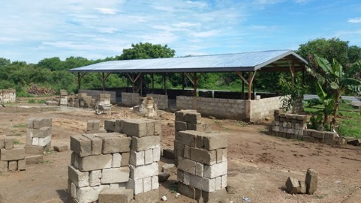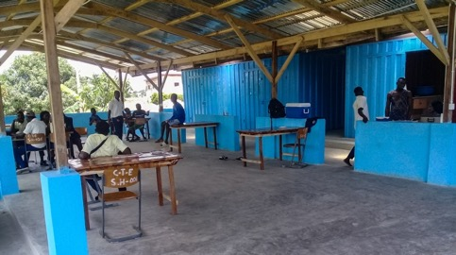
Left: Shell of Restaurant & Exhibitonhall - Right: Completed (2021)

Education secured by support association
Teachers' salaries are also covered by the association. There is also support from Recklinghausen. The "Friends of Africa" association there had previously taken over this task, but was dissolved last year. The members have joined the Lingen association, which now carries out this task from the joint membership fees. Together with the security guards, teachers and the janitor, there are 18 people who receive a regular "salary" from the association, so that education is still guaranteed.

More information about activities of the association, the CTE as well as the account data can be found on the homepage at www.cte-school-partnership-ghana.de

Translated (J.S.) and with extra photos from archive of CTE-School-Partnership-Ghana e. V. (M. Weber 11.01.2022)

